**NO OBJECTION CERTIFICATE / NOMINATION LETTER**

This is to certify that Dr/Mr./Ms. K Mayuri is working as an Assistant Professor in the Department of Computer Science and Engineering at the Institute of Aeronautical Engineering

Hereby, she is permitted to attend the AICTE-ATAL Sponsored Faculty Development Program on “***ADAPTIVE ARTIFICIAL INTELLIGENCE FOR CYBER SECURITY: FROM ANOMALY DETECTION TO THREAT MITIGATION***” (Offline Mode), scheduled to be organized by Malla Reddy College of Engineering and Technology -Maisammaguda, Dhulapally - 500100, from July 21st to July 26th**,** 2025**.**

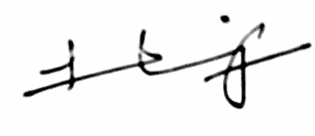

Place: Hyderabad Signature

Date: 11/07/2025 (Head of Institution/Principal/HoD)

(with Seal)